**Assignment 1**

**Visualisation**

**“Programming Languages by Users, Popularity and Years”**

* I have selected this data set from Kaggle. I have then loaded the csv file via pandas and displayed them.

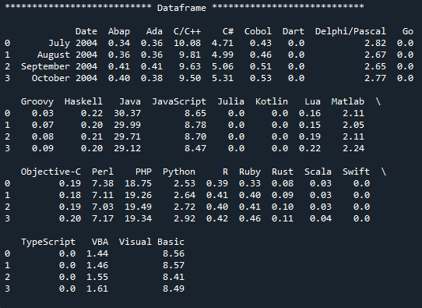

* I have then read and look through the printed data frame and called the .info() function and get some information about the data frame.

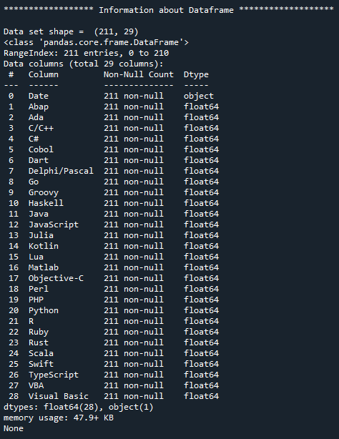

* I then had a look at the data frame for NaN by the isnull() function and could not find any null value.

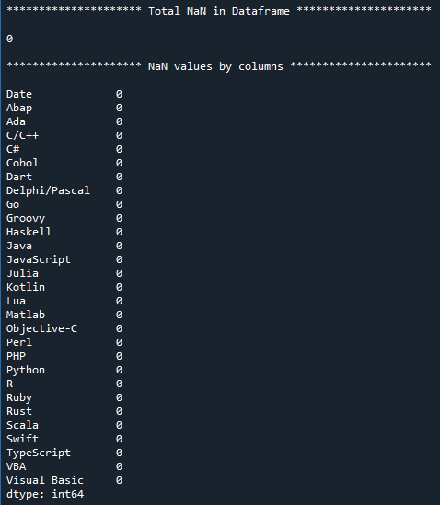

* Then I removed some languages and only took the most common ones used and dropped their respective columns and get a smaller data frame. I also converted the values of Date column which were string object to Date-time object to be able to plot the data against the actual period of years.

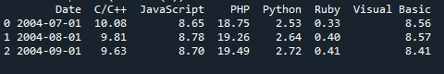

* Then I started plotting the graph of Programming languages with respect to the years, users and their popularity among users.

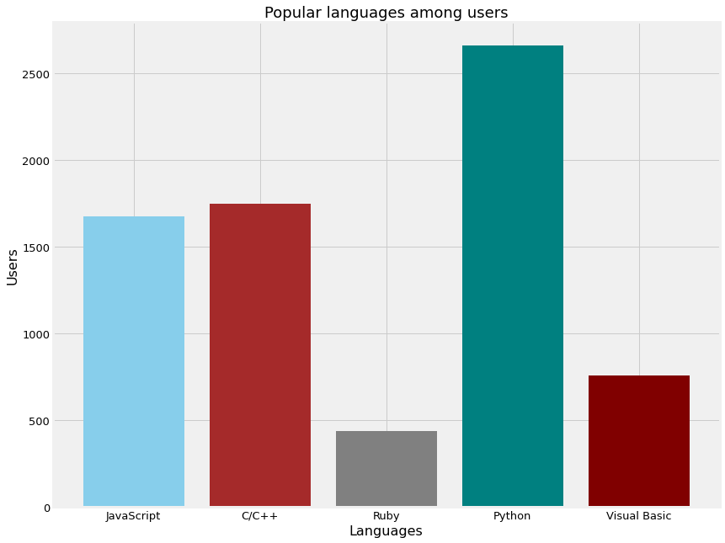

**Figure: Bar Plot**

* This Bar Chart shows the five most Common used programming languages with respect to their users over the span of 18 years from 2004 to 2022. We can easily see clearly that Python is the overall most popular or the most used among users over this span of time. I used this plot because it’s a simple way of show casing the rank of Language in terms of usage.

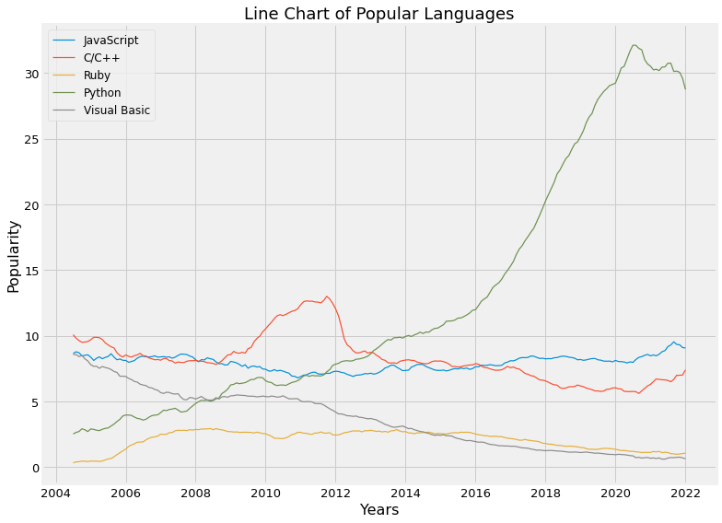

**Figure: Line Chart**

* This Line Chart shows some detailed variations across the years’ time how these languages performed with respect to popularity in percentage. Here we can see that JavaScript almost remained constant throughout decades yet Visual basic went down and is less looked at in the new times whereas C and C++ had a significant rise from 2009 to 2012 and the remained constant. Out of all Python gets the high rise from 2013 and still emerging with its application and usage in Data science and Artificial Intelligence fields.

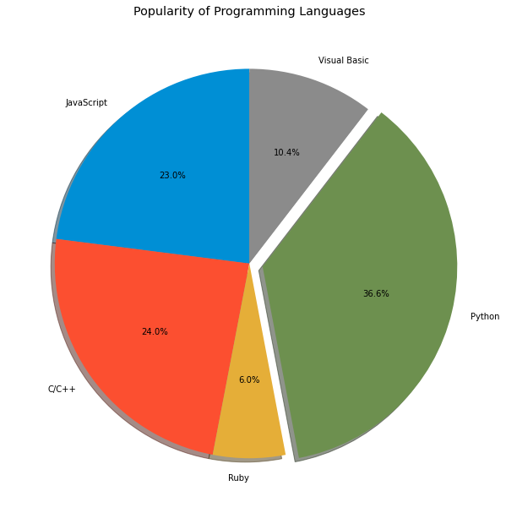

**Figure: Pie Chart**

* Pie Plot shows the visual portions of how much a language is used by Users, So Python being the most popular overall have the largest audience and hence the percentage of people using it, after comes C++/C and then JavaScript whereas Visual Basic and Ruby are the least used among the programmers and developers overall. I chose this chard because it’s a clear visualization with we can see just by looking how much portion is popular amongst the users.

*Data Source:* [*https://www.kaggle.com/datasets/muhammadkhalid/most-popular-programming-languages-since-2004*](https://www.kaggle.com/datasets/muhammadkhalid/most-popular-programming-languages-since-2004)